NAME: __________________________ DATE DUE: ____________
TEACHER: ________________________
/38
Year 11 Term 1 – Chemistry
HOMEWORK SHEET No. 1 – Atomic Structure and Isotopes

 | - Complete the missing details in the schematic below:
/11 | 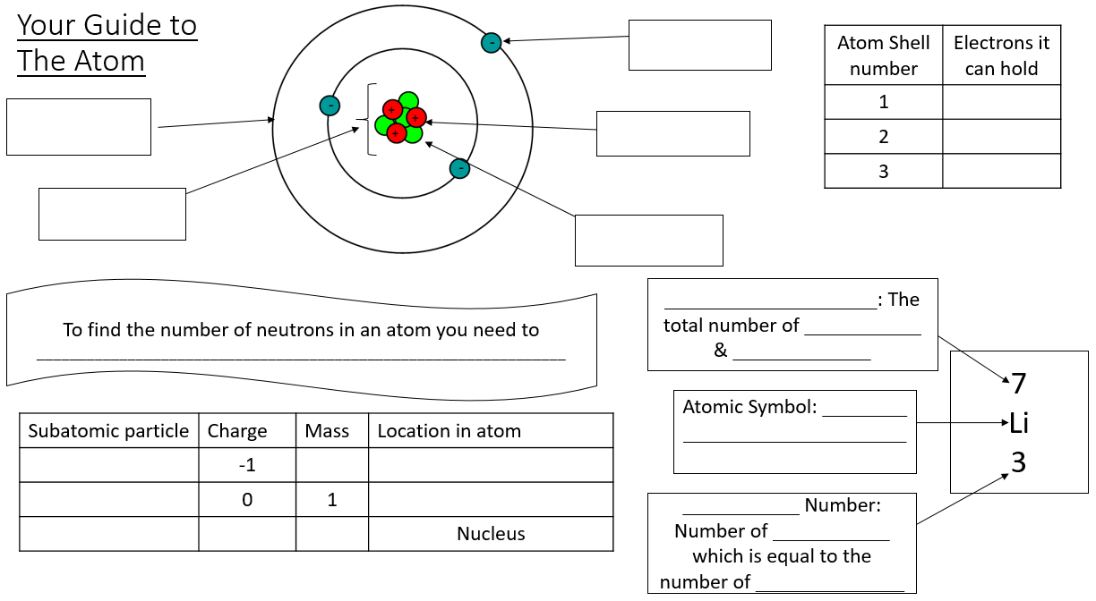  To determine the number of neutrons in an atoms, you need to:  ____________________________________________________
/4 | 2. Define the terms “ion”, “cation” and “anion” and describe how each is formed. Which grpoup of atoms in the periodic table typically form cations in chemical reactions, which group of atoms in the periodic table typically for anions, and which group of atoms in the periodic table form neither?
/4 | 3. Complete the table below  Hyphen Notation Nuclear Symbol Atomic Number Mass Number # of Protons # of Neutrons # of Electrons  Uranium  Sodium +1 ion (²³Na⁺¹) 11  Magnesium  13 14  Phosphorus  32 16

/3 | 4. Describe how the Aufbau principle, Hund’s rule, and the Pauli Exclusion principle can be used to describe the electron configuration of an atom.
/5 | a. Write the electron configuration of  (i) a Silicon atom  (ii) Oxygen  (iii) Copper  (iv) Chromium  (v) Arsenic
/1 | b. Explain why Copper and Chromium have electron configurations which are different to what would be predicted by the three rules.
/1 | 5. Define the term isotope
/2 | 6. List one reason istopes of an element will have identical chemical properties and one reason why they may have different physical properties.
/2  /2  /3 | 7. (i) Find the average atomic mass for Cl if 75.78% of Cl atoms are 35Cl with a mass of 34.96885271 amu and 24.22% are 37Cl with a mass of 36.96590260 amu.  (ii) Find the average atomic mass for Mg if 78.99% of Mg atoms are 24Mg with a mass of 23.9850419 amu, 10.00% are 25Mg with a mass of 24.9858370 amu, and 11.01% are 26Mg with a mass of 25.9825930 amu.  (ii) There are 2 isotopes of copper that occur naturally; 63Cu and 65Cu. The 63Cu atoms have a mass of 62.929601 amu and the 65Cu atoms have a mass of 64.927794 amu. What is the percent natural abundance for each isotope?

